**HUMAN COMPUTER INTERACTION**

**ASSIGNMENT NO. 2**

**[CLO1, PLO1]**

**M Muaz Shahzad 02-131202-081**

**Individual Assignment 04 MARKS**

Gestalt Principles are principles/laws of human perception that describe how humans group similar elements, recognize patterns and simplify complex images while perceiving objects.

Identify interface design or websites content which have used Gestalt principles (any 4) for organizing / structuring the website. Give snapshots and URL of the webpage (or its part) for each principle applied.

**Website URL**

https://www.smashingmagazine.com/

**Gestalt Principles**

**Similarity**

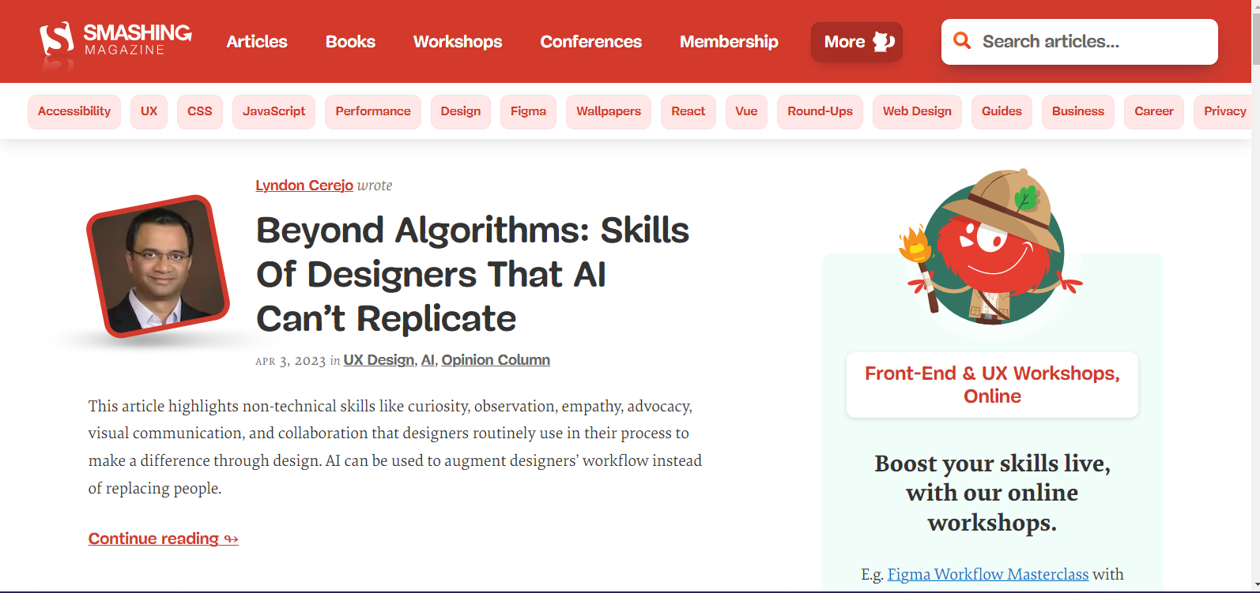

Smashingmagazine.com utilizes the similarity Gestalt principle in their website design. This is demonstrated in the uniformity of design elements such as font style, font size, and color among the navigation menu items, images, buttons, and text. The consistency of these design elements creates a visual pattern, which enhances the overall user experience. For instance, the white color used for navigation menu items such as Articles, Books, Workshops, and Membership & More implies that they lead to pages containing more information. The design and emphasis of the "More" button also follow the same pattern.

**Closure**



The Smashing Magazine logo is designed using a combination of simple shapes (circles and triangles) that are arranged in a way that creates the impression of a letter "S". This use of closure allows the viewer to mentally fill in the missing pieces and perceive the logo as a complete and recognizable shape.

****On the homepage and throughout the website, the article listings use a consistent layout and design that relies on the closure principle to create a sense of coherence. Each listing includes a thumbnail image, headline, summary, and link to the full article, which creates a complete and coherent package of information that the viewer's brain can quickly process and understand.

**Continuity**

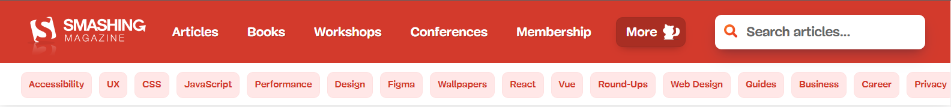

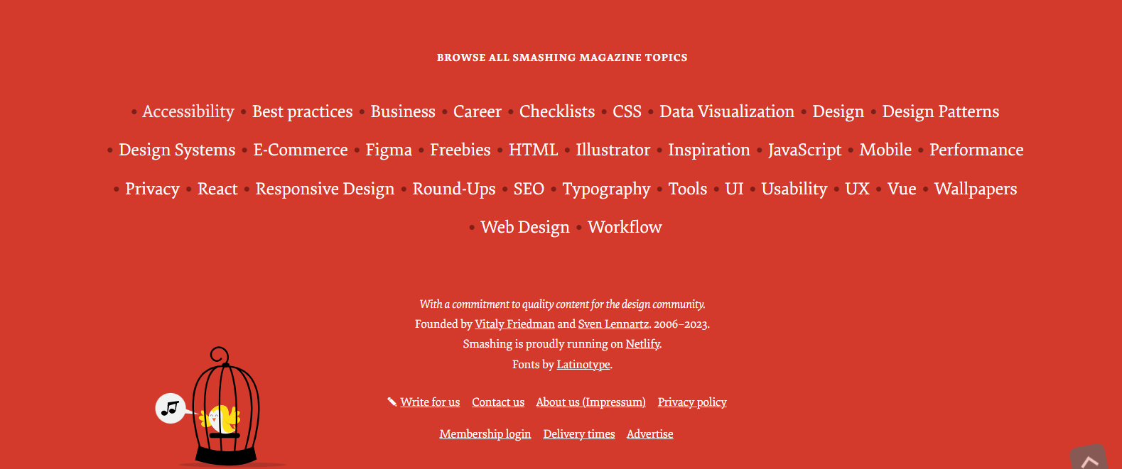

One example is the use of consistent layout and design throughout the website, which helps users navigate the site more easily. The website's header and footer sections are consistent across all pages, providing users with a sense of familiarity and helping them find what they are looking for quickly.

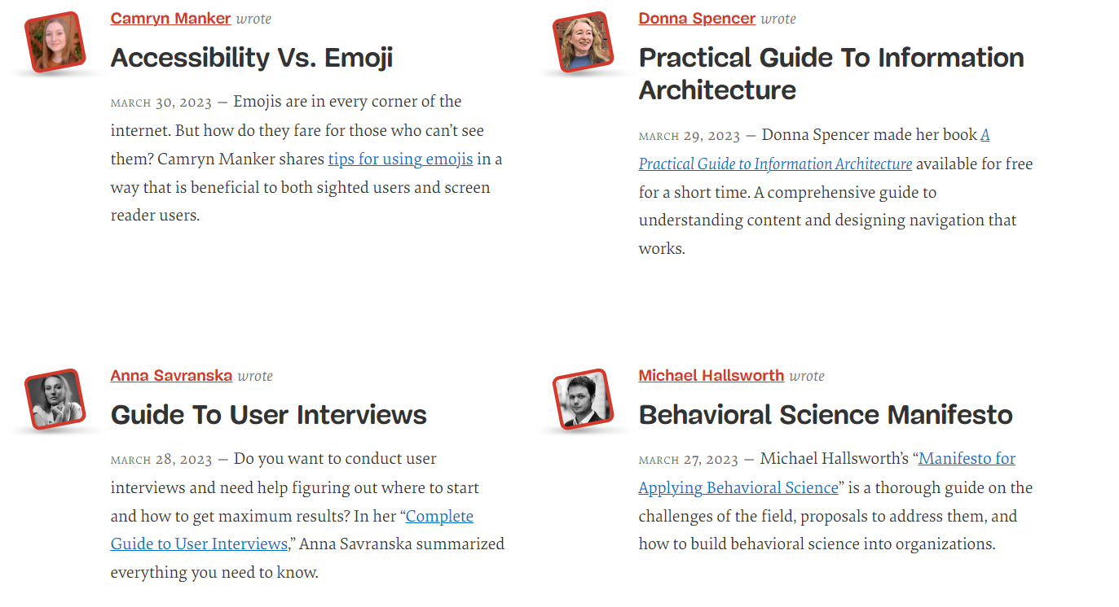

Continuity principle is the use of consistent typography and color scheme. The website uses a limited set of fonts, colors, and styles, which creates a sense of unity and coherence throughout the website. This helps users recognize important elements such as headings, links, and buttons, making it easier for them to find what they need.  
  
The website's content is structured in a way that follows a logical sequence, allowing users to easily follow the flow of information. The use of consistent headings, subheadings, and paragraphs help users understand the hierarchy of the content and find the information they are looking for.

**Proximity**

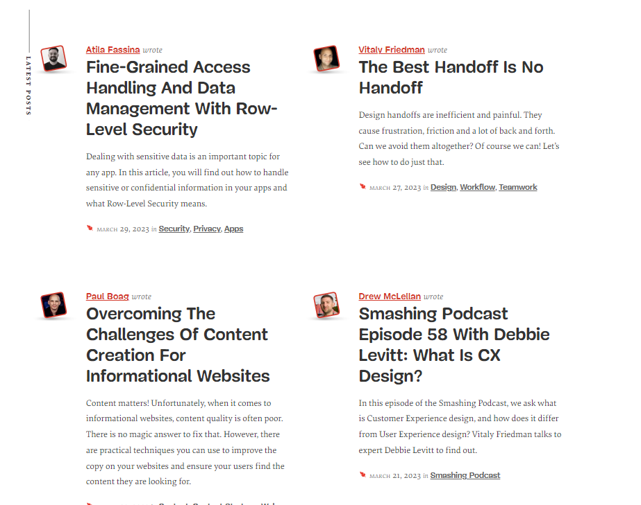

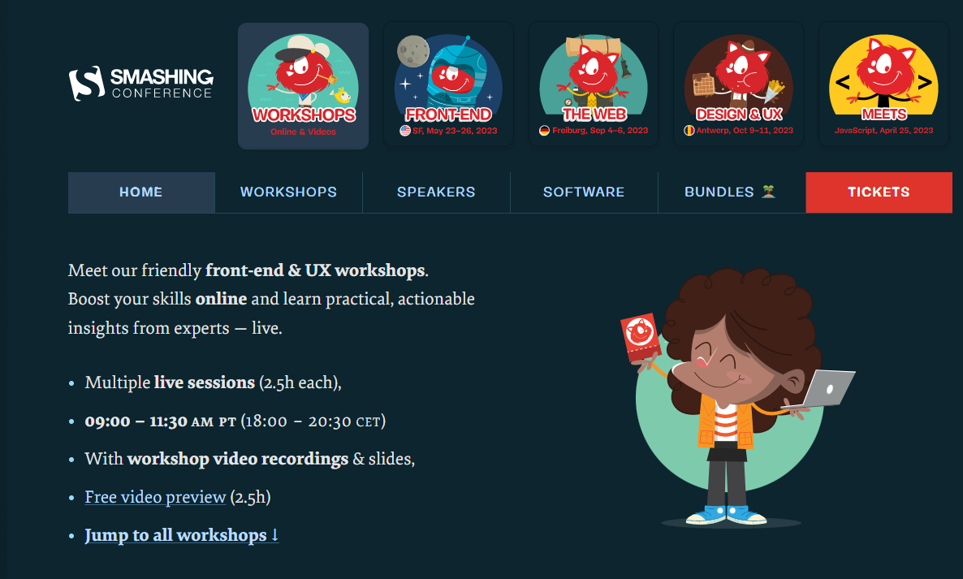

The use of grouping to organize information and guide users' attention. The website's homepage features multiple sections, and each section groups related content together. For instance, the "Latest Post" section groups articles based on their topic, and the "Upcoming Workshops" section groups workshops based on their date and location.

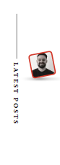

  


Another example of the proximity principle is the use of spacing to create visual hierarchy and highlight important elements. For instance, the website uses ample white space to separate headings, subheadings, and paragraphs, making it easier for users to scan and understand the content. Additionally, the spacing between images, text, and other elements helps to create a sense of visual order and balance. The proximity principle is also used in the design of the website's navigation menu. The menu items are grouped together based on their function, and each group is separated by a vertical line. This helps users quickly identify the different categories of content available on the website and navigate to their desired destination.